Job Description

Job Title: Technical Specialist - Non-Destructive Testing

Career Level: 3

Department or Business Sector:

Location: Coventry / Liverpool

Reporting to (manager’s job title): Designated Resource Manager

Heading: | Description
- Job Purpose / Impact | As a Technical Specialist, you will deliver technical excellence across a portfolio of projects, provide thought leadership on the delivery of innovative technical solutions in maturing, promising research ideas and into impactful manufacturing capability, as well as play a leadership role in the delivery of innovative project outputs;  You will own the impact of existing products and developing Value Propositions, to raise the Industrial Sectors’ awareness of the existing products and emerging value propositions whose development and impact you lead, and support the Technology Sector and Industrial Sectors in the development of their pipelines and project proposals;  You will be line-managed, coached and mentored by the designated Resource Manager as part of your own development.  To contribute to technical and business strategies by developing specific technical - and contribute to multi-theme - roadmaps that define how technology-based value propositions can be developed to meet the manufacturing challenges identified by the Industrial Sectors;  Identify collaborative research and development funding opportunities and develop winning proposals to fund the development of the value propositions you lead;  Ensure that your colleagues receive the most appropriate technical guidance and governance in the delivery of their project work;  Mentor and coach colleagues in an empathetic manner;  Provide technical governance as required for all aspects of MTC’s proposal and project delivery processes;  The Technical Specialist is also likely to take on specific responsibilities as agreed by the Technology Group’s management team, including but not exclusive of: Management of specific hardware or software; Assessment of the engineers’ and department’s technical capabilities and development needs; Development of resourcing options and team competencies.  You will horizon scan future technology, be aware of technology being researched by academia and raise awareness of potential opportunities for our business, seek internal funding, and provide sponsor’s governance of PhDs and Eng. Docs;  The Technical Specialist will be required to work closely with the cohort of Technology Managers and Technical Specialists and the management teams of the Technology and Industrial Sectors, providing specialist input to the business development, product management and technology management functions. In addition there are technical and administrative roles that also need to be performed to ensure effective delivery of our business.  In delivering this role, you will also:  General, administrative:  - Work effectively with all colleagues within MTC, the Research Partners, the Industrial Members and the wider client base;  - Engage in training programmes consistent with your needs and aspirations and those of the MTC;  - Carry out specific duties as may be reasonably requested by your line manager that are commensurate with the nature and grade of the post.
- Communication | Through your knowledge, you will provide advice and guidance to external customers, as well as internal stakeholders, on recommended strategy, opportunities and risks, as well as possible business impacts of decisions.  As a Leader in the organisation, you may be required to contribute to negotiations with external parties in a constructive way, promoting MTC’s perspective, whilst being cognisant and receptive to others’ views.  You will be able to persuade and influence both customers and colleagues of the need to adapt their approach and accept new concepts or processes, and at times be required to influence senior stakeholders in programmes on the technical direction work should follow to ensure quality of the outcome.  Where commercially allowed, you will be pro-active in reporting and presenting your work and the MTC’s capabilities in the public domain, and can articulate the vision and purpose of the MTC.  You will have the ability to be firm or assertive when appropriate, using radical candour where required.  The role also requires you to practice active listening and demonstrate the ability to use data to support recommended actions.  You must be able to communicate to all levels of the business in a professional and courteous manner ensuring that all parts of the business run as one MTC to deliver corporate objectives.
- Innovation | You will demonstrate thought leadership in your field, consistently striving to grow your expertise and MTC’s reputation, and a strong presence in critical thinking, challenging the status-quo, and able to drive quality and delivery of work to a consistently high level.  The role requires you to work collaboratively with Senior Managers and Managers from other key functions (Business Development, Programmes, Product Development, Technology Management, and Resource Management) to understand and shape current and future capability requirements and product offerings.  You will be required to be a champion in continuous improvement in technical aspects of the MTC’s project delivery capability including: Technical governance, behaviours; processes; structures; and, tools.
- Knowledge | You will be a degree-calibre engineer, technologist, scientist or mathematician.  High level of industrial experience gained in senior leadership positions, you will have a range of technical leadership skills along with knowledge and experience relating directly to the delivery of this role. You will use these to lead the activities you are responsible for.  Adept at using Microsoft toolset: Word, PowerPoint & Excel;  Technical expertise in ultrasonic inspection methods (conventional, phased array, guided waves, EMATs), alongside demonstrable in-depth knowledge of additional NDT techniques, including but not restricted to:  - Electromagnetic based inspection (Eddy current testing)  - Thermographic inspection;  - Radiation based inspection methodologies (2D X-ray, XCT);  - Image based inspection methodologies (visual inspection, hyperspectral imaging).
- Person Specification | All aspects of the role are to be carried out as an exemplar within the business in adhering to the MTC RIGHT way:  - Acting responsibly, putting MTC’s interests ahead of personal ambition;  - Providing inspirational leadership to all who come in contact with you;  - Delivering in the broadest sense a great working environment;  - Leading with humility, honesty and integrity in all that you do;  - Promoting teamwork, supporting through difficult times and collectively celebrating our successes.  Whilst not obligatory, there is a preference that you are willing and able to apply for Developed Vetting security clearance by the UK Government and undertake duties associated with this level of clearance;  In addition, you will offer:  An ability to manage relationships with, influence and negotiate with internal & external stakeholders;  Expertise recognised both internally and externally within your field, probably as a chartered engineer or scientist and Fellow of an appropriate institution.  Leadership capability and be resilient and courageous in the face of continuous change and growth, as well as being pro-active in seeing the opportunities that these create for the role you deliver;  Good decision-making capability, demonstrating diligent agility in managing concurrent tasks effectively;  An creative mind-set, able to "think out of the box", identify and resolve issues using a strongly analytical approach and challenge the status quo;  Commitment to work collaboratively and network effectively, able to recognise the contribution of others and team-work with a one MTC mind-set;
Appendix A: Operational Structures
Management Structure for Technology Groups
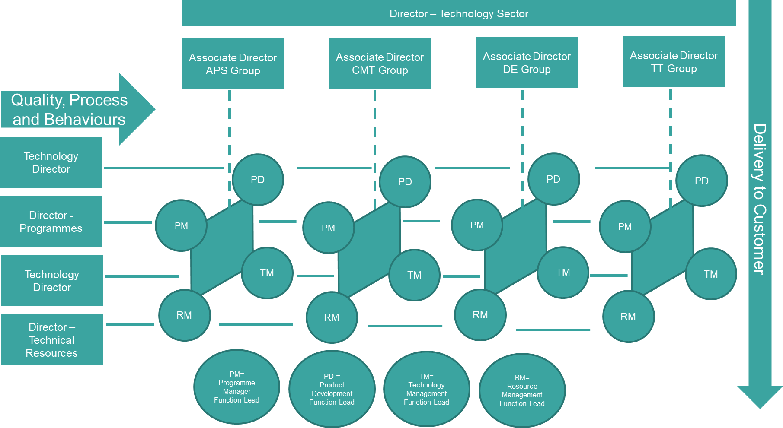

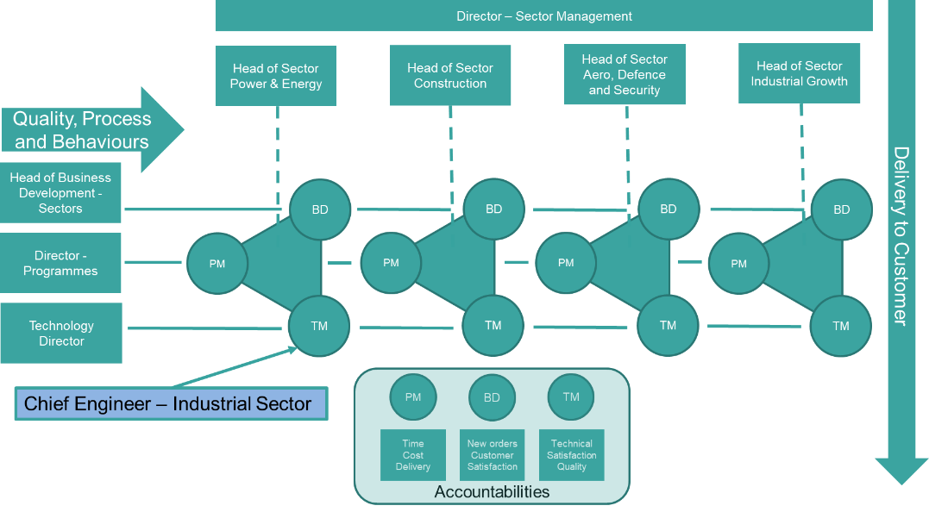
Management Structure for Industrial Sectors

Management Structure for Large Programmes
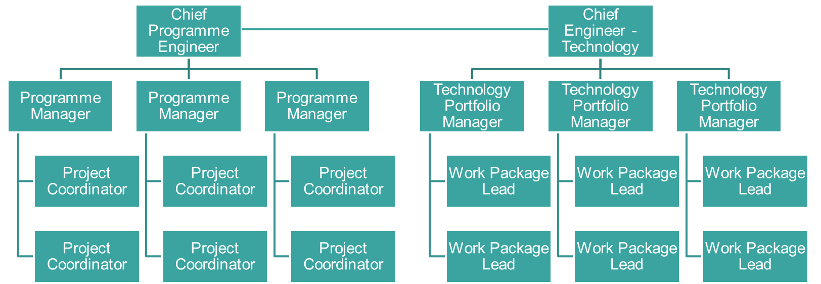
Additional Contextual Background Information
MTC Operations is focused around the maturation and application of manufacturing processes to provide societal benefit to its key stakeholders; Industry and the UK Government. This is achieved through the delivery of a portfolio of 500+ projects by a team of over 300 engineers with expertise across a broad range of technological and scientific disciplines. The project portfolio ranges from promising research ideas with generic application - which are developed through the innovation zone - to industry-ready capability for a specific sector or company. The lower readiness level research is matured in our Technology Sector business units, providing us with the products that can then be tailored to meet commercial demand by our Industrial Sector business units. Our funding model reflects this, with income from the HVM Catapult seeding our market offering, which is then advanced through winning collaborative research and development funding from local, national or international agencies or through direct industrial intervention. Projects can vary in value from £10,000 to £100M, from a week’s duration to spanning several years and may be solely delivered by MTC or with us as a project partner. The industrial sectors impacted include - but are not limited to - : Aerospace & Defence; Construction; Power & Energy; Automotive; Space; and, Fast-Moving Consumer goods. Colleagues may work on multiple projects simultaneously or be seconded to the delivery of a single, major project.

