Job Description

Job Title: Technical Specialist

Career Level: 3

Department or Business Sector:

Location: Coventry

Reporting to (manager’s job title): Technology Manager – Team Lead

Heading: | Description
- Job Purpose / Impact | As a Technical Specialist, you will provide leadership at team and group level to drive excellence within the team, helping us achieve our business goals and meet the needs of our internal and external stakeholders. This will include:  Delivering technical excellence across a portfolio of projects, providing thought leadership on the delivery of innovative technical solutions in turning maturing, promising research ideas into impactful manufacturing capability.  Supporting bringing work into the team, focussing on where we can deliver value to our clients, whilst meeting our growth targets and other metrics. This will involve identifying funding opportunities, whether industrial, CR&D or internal and supporting the development of proposals.  Contribution to technical and business strategies by developing specific technical - and multi-theme - roadmaps that define how technology based value propositions can be developed to meet the manufacturing challenges identified by the Industrial Sectors.  Ensuring that your colleagues receive the most appropriate technical guidance, mentorship and governance in the delivery of their project work.  Working closely with Technology Managers, Technical Specialists and the management teams of the Technology and Industrial Sectors, providing specialist input to the business development, product management and technology management functions.
- Communication | Through your knowledge, you will provide advice and guidance to external customers, as well as internal stakeholders, on recommended strategy, opportunities and risks, as well as possible business impacts of decisions.  As a Leader in the organisation, you may be required to contribute to negotiations with external parties in a constructive way, promoting MTC’s perspective, whilst being cognisant and receptive to others’ views.  You will be able to persuade and influence both customers and colleagues of the need to adapt their approach and accept new concepts or processes, and at times be required to influence senior stakeholders in programmes on the technical direction work should follow to ensure quality of the outcome.  Where commercially allowed, you will be pro-active in reporting and presenting your work and the MTC’s capabilities in the public domain articulating the vision and purpose of the MTC.  You will have the ability to be firm or assertive when appropriate, using radical candour where required.  The role also requires you to practice active listening and demonstrate the ability to use data to support recommended actions.  You must be able to communicate to all levels of the business in a professional and courteous manner ensuring that all parts of the business run as one MTC to deliver corporate objectives.
- Innovation | You will demonstrate thought leadership in your field, consistently striving to grow your expertise and MTC’s reputation, demonstrating critical thinking and ability to challenge the status-quo  You will horizon scan future technology, be aware of technology being researched by academia, start-ups or SMEs and raise awareness of potential opportunities for our business.  You will be required to be a champion in continuous improvement in technical aspects of the MTC’s project delivery capability including; Technical governance, behaviours, processes, structures and tools.

- Knowledge | The following are requirements of the role:  - 10+ years’ mechanical and/or manufacturing engineering experience.  - Degree educated holding one of the following; BSc, BEng, MSc or MEng in an appropriate Mechanical Engineering based subject.  - Expertise recognised both internally and externally within your field, probably as a chartered engineer or scientist of an appropriate institution.  - Can demonstrate experience of appropriate engineering Validation and Substantiation of designs, and use of Engineering controls appropriate to the project to deliver to customer requirements.  - Strong understanding of the challenges of designing, machinery, equipment and/or products.  - Extensive knowledge of materials, relevant directives, regulations and standards, mechanical principles and manufacturing techniques.  - Experienced user of CAD software packages with the ability to create design concepts and fully dimensioned drawings working to BS8888 with best practice geometric tolerances and key characteristics.  - Experience of writing and reviewing proposals, risk management and ability to accurately budget such projects.  - An ability to ideate creative solutions to complex problems and deliver on these from concept to physical realisation, both for clients and within the business.  - Demonstrable experience of identifying team and group level risks and identifying strategies to resolve them.
- Person Specification | All aspects of the role are to be carried out as an exemplar within the business in adhering to the MTC RIGHT way:  - Acting responsibly, putting MTC’s interests ahead of personal ambition;  - Providing inspirational leadership to all who come in contact with you;  - Delivering in the broadest sense a great working environment;  - Leading with humility, honesty and integrity in all that you do;  - Promoting teamwork, supporting through difficult times and collectively celebrating our successes.  In addition, you will:  - Keep up to date with team and department metrics and targets, supporting your team lead to take corrective action should we be at risk of missing our targets.  - Own personal time management, balancing the needs of the team and wider business with that of current projects, acting as a role model to the team.  - Good decision-making capability, demonstrating diligent agility in managing concurrent tasks effectively.  - Demonstrate leadership, being resilient and courageous in the face of continuous change and growth, as well as being pro-active and positive in seeing the opportunities that these create for the role you deliver.  - Commitment to working collaboratively and networking effectively, recognising the contribution of others and being a team player  - Carry out specific duties as may be reasonably requested by your line manager that are commensurate with the nature and grade of the post.  - Whilst not obligatory, there is a preference that you are willing and able to apply for Developed Vetting security clearance by the UK Government and undertake duties associated with this level of clearance.

Appendix A: Operational Structures
Management Structure for Technology Groups
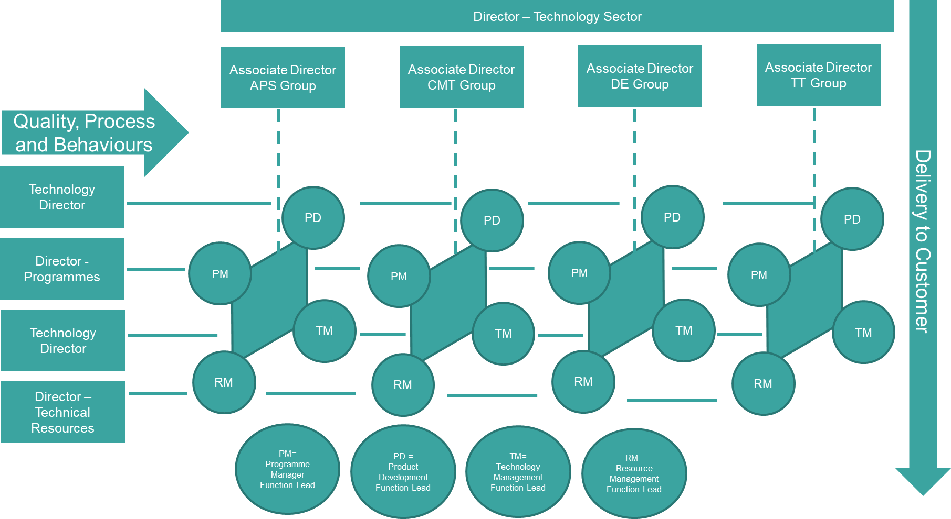

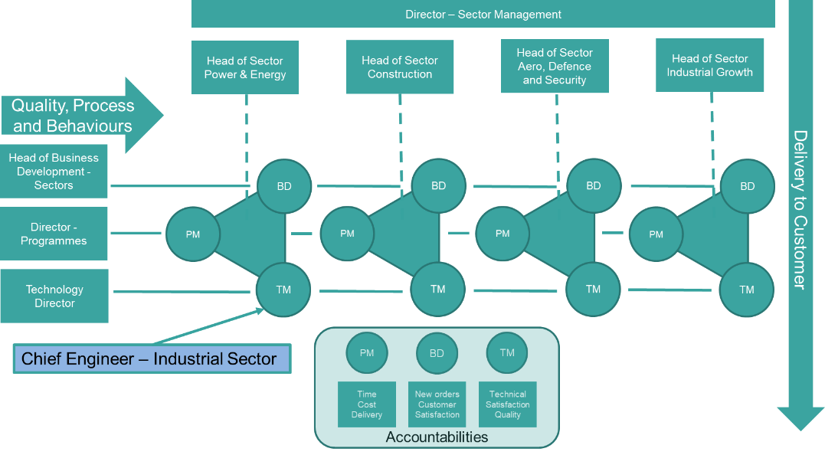
Management Structure for Industrial Sectors

Management Structure for Large Programmes
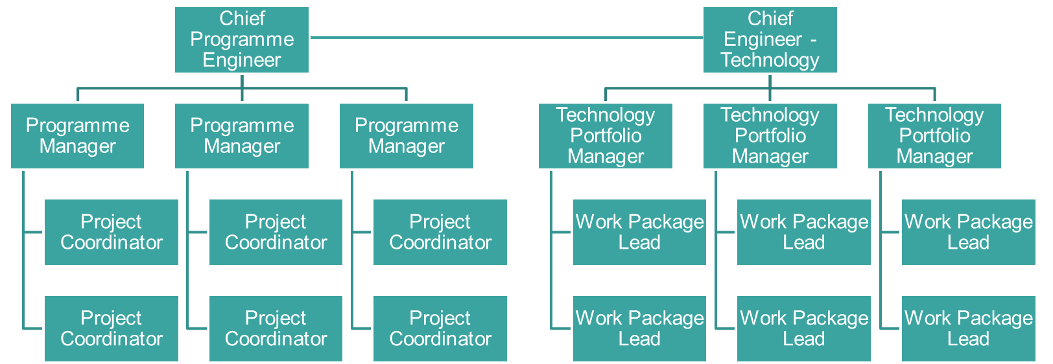

Additional Contextual Background Information
MTC Operations is focused around the maturation and application of manufacturing processes to provide societal benefit to its key stakeholders; Industry and the UK Government. This is achieved through the delivery of a portfolio of 500+ projects by a team of over 300 engineers with expertise across a broad range of technological and scientific disciplines. The project portfolio ranges from promising research ideas with generic application - which are developed through the innovation zone - to industry-ready capability for a specific sector or company. The lower readiness level research is matured in our Technology Sector business units, providing us with the products that can then be tailored to meet commercial demand by our Industrial Sector business units. Our funding model reflects this, with income from the HVM Catapult seeding our market offering, which is then advanced through winning collaborative research and development funding from local, national or international agencies or through direct industrial intervention. Projects can vary in value from £10,000 to £100M, from a week’s duration to spanning several years and may be solely delivered by MTC or with us as a project partner. The industrial sectors impacted include - but are not limited to - : Aerospace & Defence; Construction; Power & Energy; Automotive; Space; and, Fast-Moving Consumer goods. Colleagues may work on multiple projects simultaneously or be seconded to the delivery of a single, major project.

